**Ideation Phase**

**Brainstorm & Idea Prioritization**

|  |  |
| --- | --- |
| Date | 23 June 2025 |
| Team ID | LTVIP2025TMID35892 |
| Project Name | **Enchanted Wings: Marvels of Butterfly Species** |
| Maximum Marks | 4 Marks |

**Brainstorm & Idea Prioritization:**

**Butterflies play a crucial role in maintaining ecological balance as pollinators and indicators of biodiversity. However, accurate identification of butterfly species remains a challenge due to similarities in wing patterns and variations in color. The Enhanced Wings project aims to develop a deep learning-based image classification model for accurately identifying butterfly species from photographs.**

**By leveraging machine learning and computer vision, this project seeks to support researchers, conservationists, and enthusiasts in identifying butterfly species quickly and accurately. The predictive model developed can aid in biodiversity monitoring, habitat conservation efforts, and environmental education. Through automation and precision, Enhanced Wings contributes to increased awareness of butterfly diversity and promotes ecological sustainability.**

**Step-1: Team Gathering, Collaboration and Select the Problem Statement**

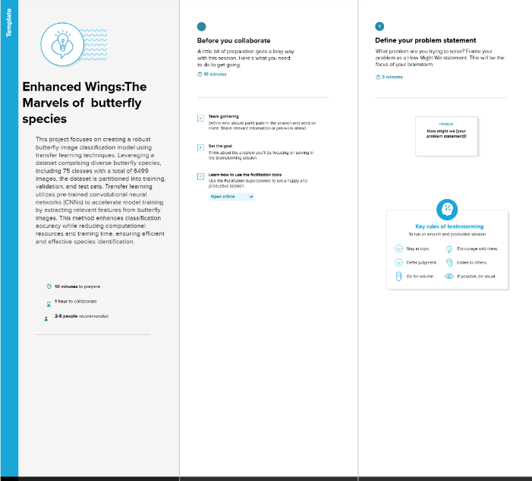

**Step-2: Brainstorm, Idea Listing and Grouping**

**📊 Data & Model Ideas**

* Use a butterfly species image dataset (e.g., from Kaggle, iNaturalist, or a custom-labeled dataset).
* Perform **image preprocessing**: resizing, normalization, background filtering.
* Apply **data augmentation**: flipping, rotation, brightness adjustments to improve model generalization.
* Use **CNN architectures** like MobileNetV2, EfficientNet, or ResNet.
* Compare models with transfer learning vs. training from scratch.
* Evaluate performance using **accuracy**, **precision**, **recall**, and **F1-score**.
* Integrate **Grad-CAM** or other visualization techniques to highlight model focus regions.

**🦋 User-Oriented Features**

* **Upload interface** for butterfly image submission.
* **Real-time prediction output**: Display predicted species, confidence score.
* **Visual badges or icons** to indicate:
  + Species name
  + Rarity (e.g., Common, Rare, Endangered)
  + Accuracy level (color-coded: green = high confidence, yellow = medium, red = low)
* Option to **save results** or view classification history.
* Display **similar species images** for visual comparison and learning.
* Educational **tooltips or fact cards** about each predicted species.

**Step-3: Idea Prioritization**

**✅ High Priority:**

* **Using a CNN model (e.g., MobileNetV2 or EfficientNet) with transfer learning is top priority due to its proven accuracy in image classification tasks and efficiency for deployment in lightweight web apps.**
* **Building a multi-page Flask web application to host the classification system, including pages for image upload, results, and information. This ensures user-friendly interaction and a clear flow.**
* **Creating the image upload form and result display is essential for core user interaction. This includes showing the predicted species, a confidence score, and a rarity/risk badge.**

**⚠️ Medium Priority:**

* **Providing educational content about butterflies (e.g., species info, ecological role, conservation status) enhances user engagement and promotes biodiversity awareness.**
* **Visualizing model attention (e.g., Grad-CAM overlays) can be useful for transparency and learning but is not mandatory for MVP.**
* **Adding image similarity comparisons (to show the closest matches from dataset) adds value but can be deferred.**

**🕒 Low Priority:**

* **User login system and result history tracking may be useful for repeat users but are not essential for the core functionality in early stages.**
* **Multilingual support for wider outreach is valuable but not required initially.**

